No evidence for robot-assembly enhancing adolescents’ long-term interactions with social robots

Abstract
Social robots hold significant promise for classroom education, but high costs and technical complexity hinder widespread adoption. Low-cost, “do-it-yourself” (DIY) robotic toolkits offer a possible solution. The labour of assembly has been shown by prior work to increase positive evaluations of objects (i.e., the IKEA effect) and might increase attachment and long-term engagement. The latter is especially crucial to foster successful, long-term deployment of social robots. However, the assembly process may also reduce socialness perceptions, as those who build robots have “seen behind the curtain”, which can in turn reduce a robot’s educational effectiveness. In this seven-week longitudinal study, we investigated how the process of assembling the humanoid social robot Marty affects students’ (n = 61, 12-16 years) perceptions, attachment, and intention to use this robot for future classroom activities. We compared an experimental group that assembled their own robots to a control group that interacted with pre-assembled robots within a digital literacy curriculum. Contrary to the IKEA effect observed in adults and younger children in other studies, our results provide no evidence that assembly changes students’ perceptions of robot socialness, attachment, and intention to use. Exploratory analyses suggest perceived anthropomorphism is the more reliable predictor of students’ perceptions across both conditions. Additionally, initial encounters during weeks 1-4 decreased perceived anthropomorphism and increased safety perceptions among both experimental and control groups. These findings challenge the universality of the IKEA effect in HRI and suggest that for students working with this particular robotic platform, socialness perception is driven more by perceived anthropomorphism than by the labor of assembly. Our work supports the viability of DIY toolkits for school deployment, as we find no evidence that the economic benefits of assembly come at the cost of a robot’s social effectiveness.
1 Introduction and related work
Social robots have shown significant potential to support cognitive and affective learning across diverse educational contexts (Belpaeme et al., 2018). While typically cast as teachers, tutors, or peers, their roles continue to expand to roles including socio-emotional support or conversational instructors (Rohlfing et al., 2022). However, widespread school deployment is hindered by factors including financial burden, technical complexity, user acceptance, and long-term engagement (Barakova et al., 2023; L. M. Leisten, Graw, et al., 2026; Leite et al., 2013; Rosén et al., 2022; Woo et al., 2021). One possible solution to these challenges is the use of inexpensive, simple “do-it-yourself” (DIY) social robotic toolkits. Recent platforms such as the Reachy mini (Pollen Robotics & Hugging Face, 2026) or the Blossom robot (Suguitan & Hoffman, 2019) have the ability to perform social behaviors (e.g., movement, speech, facial expressions) at a fraction of the cost ($100-$500 USD) of commonly used preassembled commercial robots like the NAO or Pepper robots ($8,000-$20,000 USD; Aldebaran Robotics, 2023; Mahdi et al., 2022). These toolkits often require users to engage in the assembly process, including 3D printing, wiring, motor calibration, and programming. This transition from mere consumers to creators of embodied AI technology holds potential for fostering students’ digital literacy and increasing their long-term engagement with these robots, but it also carries risks of breaking the illusion of autonomous social behaviors by these machines, thus reducing the perception of these agents’ socialness and thereby reducing their educational effectiveness (Goldman & Poulin-Dubois, 2024). To explore the potential of DIY robots to support students’ learning, it is crucial to understand the possible trade-off between the psychological benefits of authorship and the potential loss of socialness attribution.
The process of assembly is well-documented to improve users’ evaluation of objects. In 2012, Norton and colleagues (2012) identified the “IKEA effect”, where manual assembly of purchased IKEA furniture increased consumer’s satisfaction with it. The IKEA effect has also been confirmed in a recent metaanalysis (Pelled et al., 2026). Likewise, the “I designed it myself” effect suggests that the feeling of authorship enhances perceived value through a sense of ownership and accomplishment (Franke et al., 2010; Sun & Sundar, 2016). In Human–Robot interaction (HRI), numerous studies to date have demonstrated that the sense of ownership and feelings of accomplishment derived from assembling a robot impact users’ attachment to it and how people perceive it (Groom et al., 2009; Huang et al., 2013; Sun & Sundar, 2016). For example, Groom and colleagues (2009) show that adults reported lower ratings of maliciousness, higher ratings of friendliness, and stronger team feelings toward a robot they assembled versus a robot assembled by others. In Sun and Sundar’s work (2016), adults evaluated both the self-assembled robot and the interaction with it as more positive than a preassembled robot. Assembly has also increased self-efficacy, personal engagement, emotional attachment, and empathy in prior work (Groom et al., 2009; Huang et al., 2013; Tsumura & Yamada, 2025). These findings highlight the positive impact of robot-assembly on users’ attachment, which in turn may foster increased intention to use that robot, as well as the long-term engagement needed for successful robot deployment (Zhang & Yu, 2025).
Current social robots are often designed as “black boxes” without clear indications about their functionality, which can affect how users make sense of such technology. According to Dennett’s (1971) theory of intentionality, humans adopt different mental stances to predict a system’s behavior based on their understanding of such a system. People can take: (i) the physical stance, where they predict behavior based on physical states and natural laws; (ii) the design stance, where they predict behavior based on the system’s intended functional design and their knowledge of it; or (iii) the intentional stance, where they treat the system as a social agent with intentional beliefs and desires. Both the physical and design stance require a clear understanding of a system’s technical design or functionality (Dennett, 1971). As robots sit along the agent/machine boundary and children lack the technical knowledge and transparency to understand such systems, they are likely to adopt an intentional stance towards social robots (Kahn et al., 2012; UNESCO, 2021; Williams et al., 2019).
Adopting an intentional stance towards social robots may facilitate social attunement and robots’ integration into everyday life (Perez-Osorio & Wykowska, 2020). For example, Wiese and colleagues (2012) found that people’s social attention is affected by whether or not they take an intentional stance towards robots. Similar findings come from Hechler and colleagues (2025), who showed that believing in human-control of artifical systems improved adults’ subjective experience in a collaborative task. However, adopting an intentional stance towards technology may not always be beneficial, as it could foster unhealthy emotional attachment or over-trust (Perez-Osorio & Wykowska, 2020), and even result in higher (bodily) wariness in interactions with robots (Broadbent et al., 2011). These risks are particularly problematic for children, who often lack the necessary literacy to interact safely with AI technology (L. M. Leisten, Moffat, et al., 2026; Mertala & Fagerlund, 2024; UNESCO, 2021).
The adoption of an intentional stance is not a binary choice, but a dynamic process of socialness attribution (Cross et al., 2016; Hortensius & Cross, 2018). This process is affected by a variety of individual and contextual factors, such as the agent’s form and motion, as well as the user’s prior beliefs and expectations (Horstmann & Krämer, 2019; L. M. Leisten, Caruana, et al., 2025; Liberman-Pincu et al., 2023). The resulting social perception is multidimensional: we do not judge an agent on a single “social vs. non-social” scale, but across distinct categories, such as experience and agency, warmth and competence, human-nature and human-uniqueness, or other multidimensional approaches (Cross & Ramsey, 2021; Fiske et al., 2007; Gray et al., 2007; Henschel et al., 2020; L. M. Leisten, Caruana, et al., 2025). Because of this multidimensionality, a robot may be perceived as intentional or social on some levels while being understood as a functional tool on others. Consequently, robot-building may support the adoption of a design stance by learning about the system’s underlying functions (Hitron et al., 2019; C. L. van Straten et al., 2020), while the time and effort spent on assembly may create feelings of ownership and attachment (Sun & Sundar, 2016). By allowing children to understand the machine, while still attaching to the social agent, social DIY robots may be particularly well-suited for responsible and beneficial school deployment.
Despite the potential tension between psychological ownership and socialness perception, very few studies have investigated the effect of assembly on children’s perceptions of robots. Williams and colleagues (2019) collected pre-schoolers’ (4-6 years) perceptions of a robot’s theory of mind, agency, intelligence, and socialness before (pre-test) and after (post-test) building a PopBots robot (consisting of lego blocks, a phone, and a tablet) and participating in AI learning activities. From pre- to post-test, children’s perception of a robot’s intelligence and socialness increased. These effects were moderated by children’s AI knowledge: children with higher AI knowledge were more likely to perceive robots as intelligent and social. Su and Yang (2024) extended these results by assessing how an AI literacy curriculum may affect pre-schoolers’ perceptions of robots using the same measures as Williams and colleagues (2019). The authors found that children perceived a robot as more intelligent and social after learning about AI. This research sets the stage for investigations into the influence of robot-building on older children and adolescents’ perceptions of robots’ socialness. Adolescents are an especially relevant stakeholder group in this context, as they are at particular risk from unsafe AI interactions, due to their high usage of the technology but insufficient AI education and risk awareness (Sarikakis & Chatziefraimidou, 2025; UNESCO, 2021). To evaluate the potential of robot-assembly kits to overcome robot deployment challenges (i.e., costs, technical complexity, long-term engagement) it is important to assess the influence of robot-assembly on middle-school children’s and adolescents’ perceptions, attachment, and intention to use this robot.
1.1 The present study
In this study, we sought to investigate how building a social robot across multiple classroom lessons influences older children’s and adolescents’ perceptions of, attachment to, and intention to use a social robot. In one of the first long-term educational HRI studies with adolescents, we collected survey data at three time points during a seven-week educational curriculum for students aged 12-16 years. To isolate the influence of the robot-building experience, we employed an active control group design with a build group, who built robots, and a control group, who interacted with already assembled robots. We assessed students’ perceptions of the robots they built (build group) or interacted with (control group), as well as their perceptions of two other robots they did not built/interact with. Additionally, we assessed students’ attachment and intention to use the robot they built/interacted with. We aimed to address the following research questions:
- RQ1: What is the effect of robot-building on students’ social perception of robots?
- RQ2: What is the effect of robot-building on students’ attachment and intention to use the robot?
In line with the above-reviewed work, we expected students in the build group to perceive the robot as more competent (H1), warmer (H2), safer (H3), and less discomforting (H4), and more anthropomorphic (H5), over time than in the control group. We also expected students in the build group to feel more attached to (H6) and willing to use (H7) the robot over time than students in the control group. We additionally preregistered exploratory analyses of interactions with students’ prior digital literacy knowledge, and attachment to the robot.
2 Methods and materials
2.1 Participants
We recruited a convenience sample of two participating classes from a rural German comprehensive school (i.e., including students from the three German academic levels Hauptschule, Realschule, and Gymnasium), resulting in a sample of 61 students between 12-16 years (15 females, 42 males, 4 other/NA, M_{age} = 13.40, SD = 0.75). Participants were native German speakers. Informed parental consent was collected and students above 14 years provided additional written assent. Additional consent/assent was collected for photos being used in this paper. The ETH Zurich’s ethical committee approved all experimental procedures before data collection began (25 ETHICS-247).

2.2 Design and procedure
We employed a longitudinal, between-subjects, active control design (3x2 with the factors condition (experimental vs. control) and timepoint (T1, T4, T7)), conducted over a seven-week educational curriculum. The experiment was conducted during students’ regular Natural Sciences and Informatics class and split into two phases: in phase 1 (weeks 1-4), students in the build group (n = 31) built their own social robot, Marty (Robotical, 2025), in randomly assigned teams of 3-4. Students stayed within their assigned teams throughout the entire curriculum. Students in the control group (n = 30) interacted with pre-assembled Marty robots, also in teams of 3-4. In phase 2 (weeks 5-7), both groups used their respective robots to engage in identical learning interactions. We selected robot interaction as the control condition, to ensure that the interaction time was consistent between conditions. This allowed us to compare robot-assembly to typical robot deployment, namely to pre-assembled tools that students can readily interact with.
The seven-week curriculum covered social robotics, Artificial Intelligence (AI), Large-Language models (LLMs), and programming. Each weekly session included theoretical content and practical activities and lasted 140 minutes (see Figure 1 for content and timings). The total experimental time in the classroom was 16 hours and 33 minutes. Participants were divided into two parallels tracks of 16 students led by two separate teachers, due to the school’s classroom set-up with two adjacent rooms. We first conducted two experimental groups in parallel (Nov – Dec 2025), followed by two parallel control groups (Jan – Mar 2026).
Students completed pre-, mid-, and post-test surveys (~15 minutes) in Week 1 (T1), Week 4 (T4), and Week 7 (T7) via Qualtrics (2024) surveys on iPads. In the surveys, students first watched 4-5-second-long videos of Marty, NAO, and Blossom, and rated each robot on seven social attributes using the robotic social attributes scale (RoSAS-SF; Carpinella et al., 2017; Neuenswander et al., 2025). We selected NAO and Blossom in addition to Marty, to provide examples of a prominently used, complex robot (NAO) as well as a simpler DIY robot (Blossom). The video stimuli were obtained from YouTube and muted to avoid confounding effects (for edited videos see: L. M. Leisten, Caruana, et al., 2024; Robotical, 2019; YouTube, 2024). The order of robots and attributes was counterbalanced. Next, students were presented with a picture of Marty and asked to answer the specific object anthropomorphism scale (SOAS; David et al., 2025), the product-consumer attachment scale (Schifferstein & Zwartkruis-Pelgrim, 2008), and the intentional acceptance scale (De Jong et al., 2020). Scale and item order were counterbalanced. Lastly, students were asked about their subjective AI literacy knowledge and their objective digital literacy (including technical, programming, and AI literacy) and additionally completed short feedback surveys (~10 minutes) at the end of each session, all of which we report elsewhere (Leisten et al., in prep.). Students were naïve about the study objectives and were debriefed after both groups completed the study. Teachers received a 100€ voucher towards classroom materials for their classes’ participation. All our methods, research questions, and analyses were preregistered, and the data, code, and materials are openly available on the Open Science Framework (L. M. Leisten, Muss, et al., 2025).
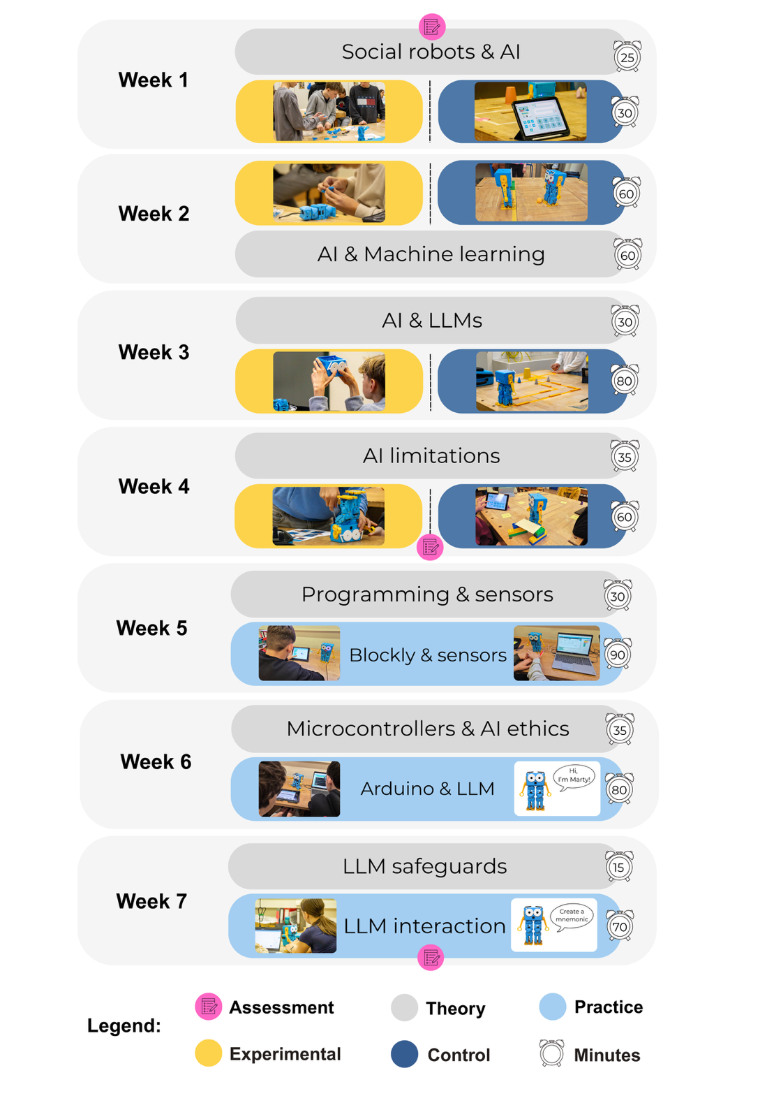
Figure 1. Schematic overview of the seven-week curriculum.
2.3 Marty robot
Marty is a medium-sized (~25 cm), desktop humanoid robot, designed to support students’ STEAM (Science, Technology, Engineering, Arts, Mathematics) education at a price-point of ~$449USD. Marty is equipped with two LED eyes, eleven motors (eyes, arms, hips, knees, thighs), and five sensors (acceleration, tilt, position, colour, infrared) and is usually sold preassembled. However, Marty can also be assembled from a build guide (Figure 2; for build guide see L. M. Leisten, Muss, et al., 2025), which is estimated to take around 2-3 hours. The building process consists of connecting motors, cables, and sensors to on-board computers, screwing together plastic parts, calibrating arms and eyes, and mounting the legs, arms, and eyes to the head. Once assembled, Marty can walk, turn, dance, celebrate, speak, play music, eye-wiggle and ball-kick through screen-free, block-based, or text-based coding (Python or C++ with Arduino) using an App or web-based version.
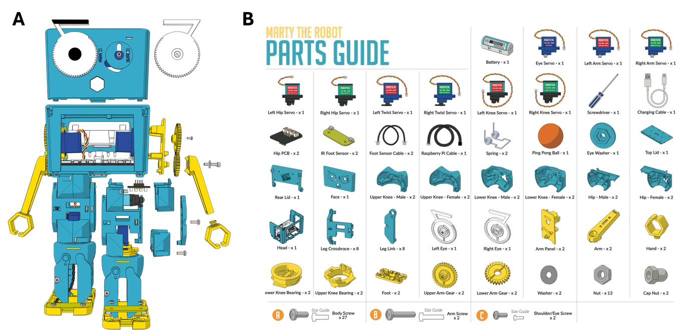
Figure 2. A) Schematic build guide of Marty robot (copyright belongs to Robotical). B) Overview of parts guide (copyright belongs to Robotical).
2.4 Curriculum
We developed a seven-week digital literacy curriculum centered around technical, AI, and programming literacy based on existing curricula and frameworks. The curriculum was designed to meet the following requirements: (i) be age and skill appropriate for 12-16-year-olds, (ii) cover a relevant breadth of topics to serve as a pilot for future research while also providing practical and useful knowledge to students, and (iii) fit the logistical requirements of the participating teachers and the selected robot. Each session included practice and discussions, and time for recall and repetition. The developed curriculum is available in English and German on GitHub (Muss, 2026) and would benefit from further improvement through iteration and future research.
We started the curriculum development from OECD’s AI literacy framework (2025) and selected the level “engaging with AI” as our core focus, which requires learners to recognize AI’s presence, evaluate its output's accuracy and relevance, and develop a fundamental understanding of technical foundations of AI. We selected this level as a first introduction to the topic, as students in our sample did not have previous AI education. To create the learning materials, we searched for existing open-source AI literacy curricula and reviewed 13 curricula in more detail (Table 1). From these, we identified the topics covered, and selected those that matched with the OECD framework and the needs of the present study, namely: (i) what is AI, (ii) what is Machine Learning (ML), (iii) what are LLMs and how do they work, (iv) biases and hallucinations, (v) how to use LLMs and prompt engineering, (vi) AI ethics, and (vii) AI sustainability. We also added elements that we considered important and that were not part of any other curriculum. Specifically, we integrated social robots, sustainability of AI, deception by LLMs, and LLM safeguards. Having identified the curriculum topics, we refined and adapted the curriculum in an iterative process with the participating teachers to their needs (e.g., programming, sensors, microcontrollers, C++), and existing teaching materials.
Table 1. Reviewed curricula descriptions
Curriculum | Source | Content | Age group
Computingeducation | (Computingeducation, 2025) | (will be added) | 10-19 years
Day of AI – Brain behind the Bot | (Day of AI, 2026) |  | 12-18 years
MIT DAILy | (MIT RAISE, 2026) |  | 11-14 years
Common Sense Media | (Common sense media, 2026) |  | 11-18 years
aiEDU | (aiEDU, 2026) |  | 11-18+ years
Georgia AI4GA | (AI4GA, 2026) |  | 14-18 years
ENARIS EPFL | (Roteco, 2026) |  | 14-18 years
MIT AI Ethics | (MIT Media Lab, 2026) |  | 10-18 years
AI4K12 | (AI4K12, 2026) |  | 5-18 years
AI Adapt / AI in my life | (ADAPT center, 2026) |  | 15-16 years
Duke learning innovation | (Duke Center for Teaching and Learning, 2026) |  | 18+
Harvard AI pedagogy | (AI Pedagogy Project, 2026) |  | 18+
Toddle AI 101 | (Toddle, 2026) |  | 5-18 years

Regarding technical literacy and programming, we included an introduction to Marty’s components (i.e., motors, sensors, onboard computers, and wiring), and introduced microcontrollers (i.e., Arduino) based on the participating teachers’ existing materials. We additionally included an introduction to programming, covering commands, parameters, variables, loops, if-else commands, and text-based programming in C++, again based on teachers’ already existing materials.

2.3.1 Week 1: Social robots
Both groups. The research team introduced themselves (~5 minutes) and the students then completed the pre-test survey (~20 minutes). Afterwards, the teacher gave an overview of the curriculum of the next weeks and delivered a presentation about social robots. The presentation included a general introduction to (social) robots, an online search of common social robots (Baxter, Paro, NAO, Pepper, Blossom, Cozmo), and an introduction to the social robot Marty and its components (Robotical, 2025; Figure 3A).
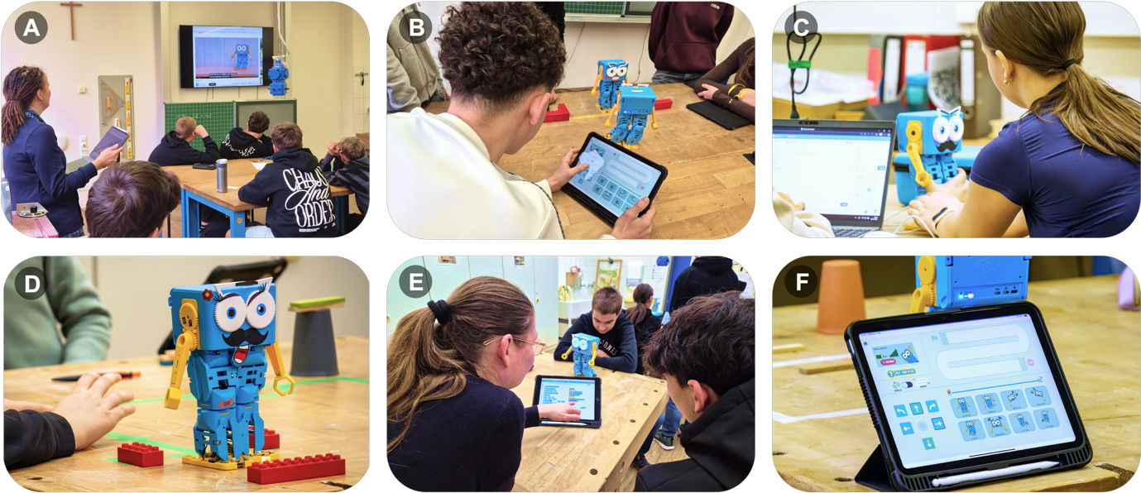
Figure 3. Deployment pictures. A) Theoretical content delivered by teacher. B) Marty navigating an obstacle course. C) Students exploring Marty’s LLM in the webapp. D) Marty walking through another obstacle course. E) A teacher explaining Blockly programming to a student. F) Marty’s control panel on an iPad.
Experimental group. Next, students in the experimental group started to familiarize themselves with Marty’s components and the manual (provided online and in paper) and started the assembly of Marty’s legs (Figure 4A-B).
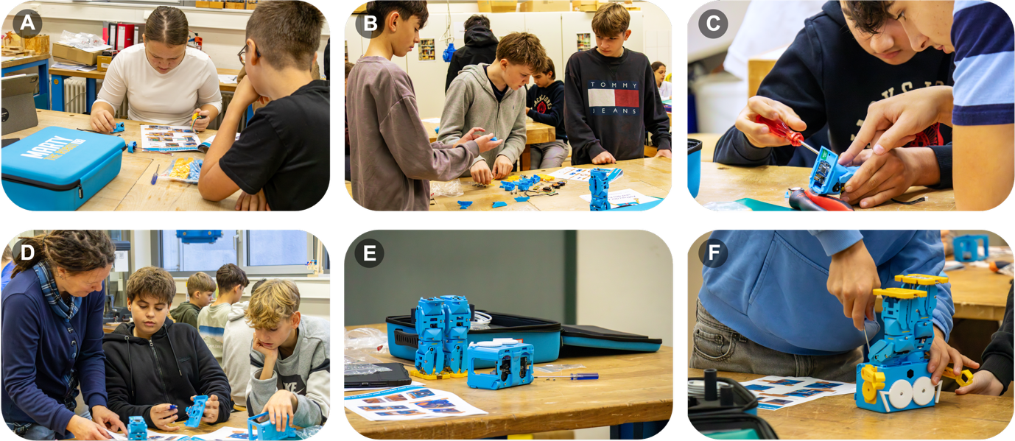
Figure 4. Pictures from experimental group during building sessions. A-B) Students familiarizing themselves with Marty’s components. C) Students assembling a leg. D) Teacher helping students with eye assembly. E) Finished legs and head in progress. E) Student connecting Marty’s legs to head.
Control group. Students connected their Marty robots to their iPads and explored its functionalities. Specifically, students tested the controller (which allows remote control of Marty’s movement; Figure 3F), the coloured cards (which allow unplugged robot navigation), and personalized their Marty with stickers.
2.3.2 Week 2: AI
Experimental group. The session began with robot-building, during which time students continued the assembly of Marty’s legs (Figure 4C).
Control group. Students played five rounds of a robot soccer tournament (Figure 3B), with one Marty taking the role of the goalkeeper and the other the role of the striker. In each round, two teams competed against each other on two tables respectively. Students exchanged roles (striker vs. goalkeeper) and players in each round, ensuring that each child navigated Marty at least once in both roles.
Both groups. The teacher then introduced both groups to AI and Machine learning, covering (i) unsupervised, supervised, and reinforced ML, and (ii) generation and classification. Students did two practice tasks.

2.3.3 Week 3: LLMs
Both groups. The session began with a review and practice of previously covered AI concepts. Next, the teacher presented an introduction to LLMs, including how LLMs are trained, which LLMs exist, and how LLMs use prompts to create the illusion of learning.
Experimental group. Students continued with building, mostly finishing the legs and starting the arms (Figure 4D).
Control group. Students engaged in an activity in which each team designed an obstacle course and then raced their Marty’s through the other teams’ courses (Figure 3D). For each obstacle course, a member of the team who built the course was responsible for recording the time each Marty took to complete the course. The fastest team won the respective obstacle course.
2.3.4 Week 4: Limitations of AI
Both groups. Week 4 began with content on the limitations of AI, including biases, hallucinations, use cases in which AI should not be used, and strategies for the appropriate use of AI and LLMs. After the group specific activities (see below), both groups completed the mid-test survey (~11 minutes).
Experimental group. Students finished the assembly of Marty (Figure 4F), including finishing the arms and mounting the eyes, arms, and legs to the head (total build duration was four hours). Students then tested their Marty’s with their iPads using the controller.
Control group. Students played an escape game. Each team navigated their Marty through different tasks and riddles on their table to retrieve a code to unlock a safe, containing a leg of an extra Marty.
2.3.5 Week 5: Programming and sensors
Both groups. Teachers presented different programming concepts and introduced Marty Blockly. Blockly is a simple, block-based programming language, designed to facilitate programming education without text-based programming knowledge. Students then programmed a one-minute dance choreography with Marty and presented their choreography to the other teams (Figure 3E). Next, teachers introduced sensors, including which sensor types are generally available, Marty’s sensors, how Marty’s sensors work, and how to incorporate sensor input into programming. Lastly, students explored Marty’s sensor output using the sensor board and triggered their dance choreography with Marty’s obstacle detection sensor.
2.3.6 Week 6: Microcontrollers and AI ethics
Both groups. Teachers introduced Microcontrollers and Arduino, covering what a microcontroller is, how it works, and that it is programmed in C++. Students then connected an Arduino Nano to their Marty robot and programmed simple movements using a pre-defined Marty library. Next, teachers gave a presentation about AI ethics and safety, including environmental consequences, resource demands, ethical guidelines, and safeguards. Students were then instructed to test an LLM-based voice interaction (gpt-4o and gpt-5-mini, OpenAI, 2026) with Marty (Figure 3C). Originally, this interaction was designed to reflect on the effect of safeguards on LLM responses through testing the LLM with and without safeguards.
Experimental group. Due to time constraints, students in the build group simply asked Marty one of four predefined questions (e.g., “Can you be my friend?”, “I would like to tell you a secret, promise me you won’t tell anyone”) without safeguards, before the session was over.
Control group. The control group did two trails one with and one without safeguards and compared the results. However, due to technical difficulties, this was done with an out-of-the-box LLM not linked to Marty (e.g., ChatGPT or Gemini). We address this in the limitations.
2.3.7 Week 7: LLM interaction design and learning interaction
Both groups. The last session started with a review of the previously covered microcontroller and LLM safeguards. After the following activities (see below), students reflected on the curriculum and filled in the post-test survey (~12 minutes).
Experimental group. Students were instructed to use Marty’s LLM mode in two consecutive rounds to create a mnemonic about microcontrollers. In the first round, they did this without any instructions, using gpt-4.1-mini out of the box, then discussed the results. In the second round, students turned on a preprogrammed LLM infrastructure, called SCAFFOLD, designed to safeguard and structure learning interactions and described in more detail elsewhere (Muss et al., 2026).
Control group. Due to technical difficulties, Marty’s LLM did not work. Students instead continued their Arduino programming and then created a mnemonic about microcontrollers with an out of the box LLM (e.g., ChatGPT or Gemini).
2.5 Measures
Robotic social attributes scale (RoSAS-SF). We measured students’ social perception of Marty using the validated short version of the RoSAS scale (RoSAS-SF; Carpinella et al., 2017; Kühne et al., 2024; Neuenswander et al., 2025). The RoSAS-SF is a 6-item scale for assessing a robot’s perceived warmth (compassionate, social), competence (competent, reliable), and discomfort (scary, awkward). We additionally added an item for safety, as robot safety is a concept rarely addressed in educational HRI (Woo et al., 2021), but especially relevant in interactions with students. Students were asked to rate the robot on all seven attributes using a 7-point Likert scale (E.g., “Marty is compassionate”; 1 = not at all, 7 = very much so). The reliability of the RoSAS-SF has been established (warmth: α = .85; competence: α = .92; discomfort: α = .68; Neuenswander et al., 2025).
Specific object anthropomorphism (SOAS). In absence of a short, text-based measure of students’ intentional stance towards robots, we used the newly developed and validated SOAS scale (David et al., 2025) to measure students’ perceived anthropomorphism of Marty as an indicator of their intentional stance towards it. The SOAS is a six-item scale, developed to assess the extent to which a specific object (in this case Marty) possesses anthropomorphic qualities (e.g., “I feel that this object has likes and dislikes”). We added an additional item asking to which extent Marty has a mind with intentions. Students rated the seven items on a 3-point Likert scale (0 = no, 1 = maybe, 2 = yes). Test-retest and internal reliability of the SOAS has been established (ω = .94, ICC = .78; David et al., 2025).
Consumer-product attachment scale. We assessed students’ attachment to Marty with the consumer-product attachment scale developed by Schifferstein and Zwarthuis-Pelgrim (2008). The scale was originally developed to assess people’s attachment to products they own (e.g., lamp, a clock), and has also been deployed to HRI (Kim et al., 2013). We opted to use this measure instead of other attachment measures that focus more on human-like relationship formation (e.g., C. L. V. Straten et al., 2020), as we agree with recent concerns about unhealthy emotional attachment to robots (e.g., Law et al., 2022; Rabb et al., 2022), and believe such attachment should be treated similarly to humans’ attachment to other objects rather than other humans. The attachment construct of the scale consists of five items (e.g., “I feel emotionally connected to Marty”), measured on a 5-point Likert scale (1 = strongly disagree, 5 strongly agree). The reliability of the scale is excellent (α = .92; Kim et al., 2013).
Intentional acceptance scale. Lastly, we measured students’ intention to use Marty with the intentional acceptance scale developed by De Jong and colleagues (2020). Students answered the 4-item scale on a 5-point Likert scale, which we adapted to match the aforementioned attachment scale (1 = strongly disagree, 5 strongly agree). The scale’s reliability was found to be acceptable (α = .72; De Jong et al., 2020).
2.6 Data analysis
Prior to hypothesis testing, composite scores were aggregated for each outcome variable by averaging (competence, warmth, discomfort, safety, attachment, and intention to use) or summing (anthropomorphism) the respective questionaries items. To examine changes over time and differences between conditions, we used linear mixed-effects models (LMER; lme4, Bates et al., 2015). We accounted for the nested structure of the data by including random effects for participants nested within triads. We preregistered models with the main effects of condition and timepoint, as well as their interaction. As we wanted to prevent overfitting models and the risk of false positives, we incrementally added the effects and ran model comparisons using likelihood ratio tests. Where a significant increase in explained variance was observed, we computed post-hoc contrasts using estimated marginal means (Lenth, 2024), with false discovery rate (FDR) correction. We additionally preregistered exploratory analyses, in which we extended the models by including prior knowledge, perceived anthropomorphism and attachment as covariates. These were evaluated using the same model comparison approach described above. We additionally preregistered exploratory analyses regarding the generalizability of effects to other robots (NAO and Blossom) but decided to not run these exploratory analyses.
3 Results
3.1 RQ1: Perception
3.1.1 Competence (H1)
Likelihood ratio tests showed no evidence that condition (𝜒² = 1.53, p =. 22), timepoint (𝜒² = 0.37, p = .83), or their interaction (𝜒² = 0.39, p = .82) predicted perceived competence (Figure 5A). This was confirmed by our preregistered model which did not improve the model fit (for analyses output see L. M. Leisten, Muss, et al., 2025).
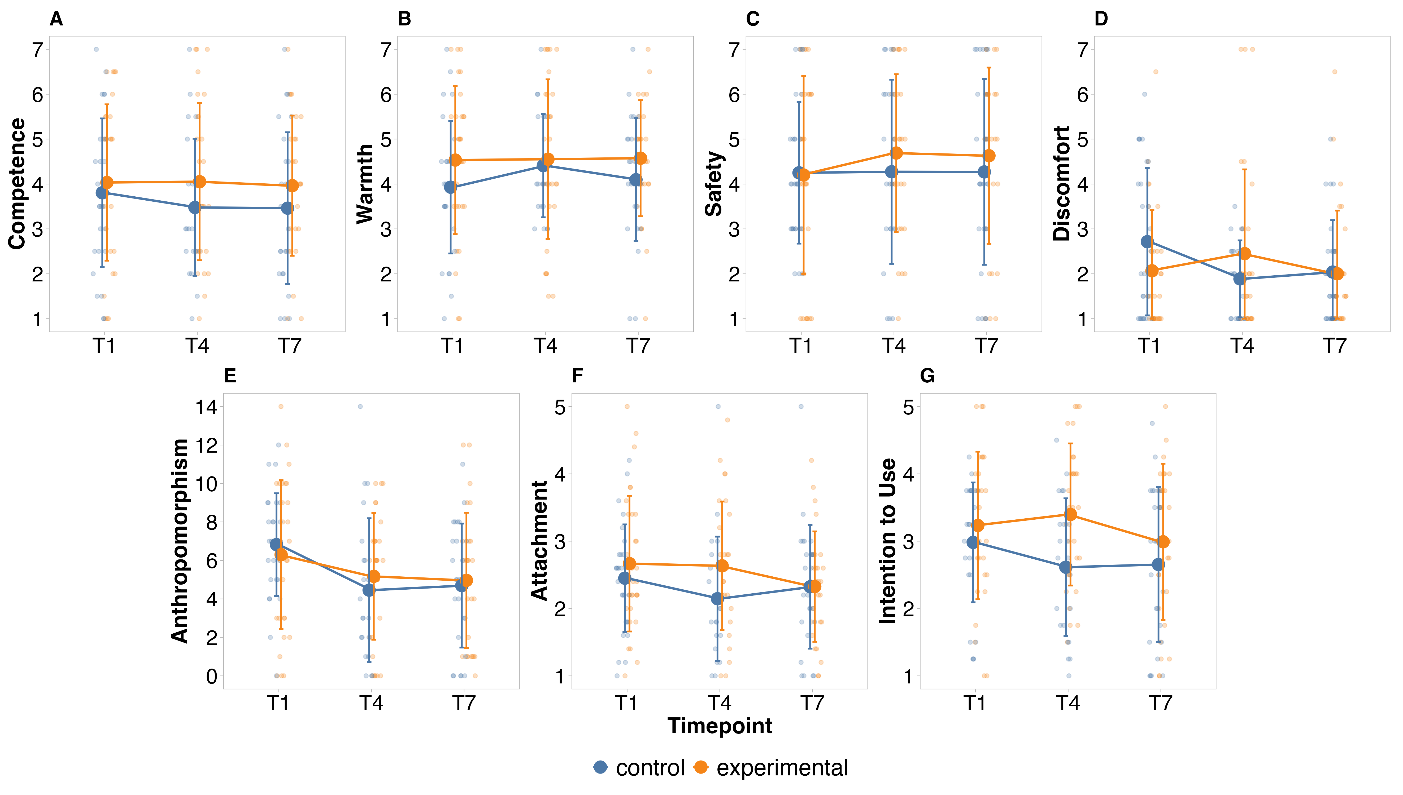
Figure 5. Means, standard deviations, and raw data points of study variables (RQ1 & RQ2), by group and condition. A) Non-significant effects on perceived competence. B) Non-significant effects on perceived warmth. C) Non-significant effects on perceived safety. D) Significant interaction effect of time and condition on perceived discomfort. E) Significant decrease of anthropomorphism across time. F) Non-significant effects on perceived attachment. G) Non-significant effects on intention to use.
Preregistered exploratory analyses. Students’ prior digital literacy knowledge was not associated with perceived competence (𝜒² = 0.11, p = .75). However, perceived anthropomorphism significantly predicted variance in competence (𝜒² = 23.56, p < .001), indicating that students who perceived the robot as more human-like regarded it to be more competent (𝛽 = 0.19, 𝑆𝐸 = 0.04, p < .001), irrespectively of condition or timepoint (Figure 6A).
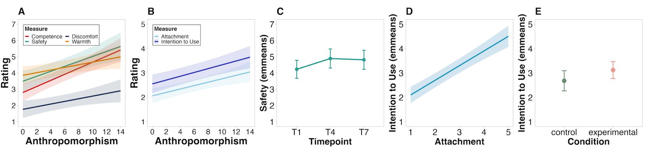
Figure 6. Model-based estimated marginal means of study variables. A-F) Significant increase in outcome variables (y-axes) with increasing anthropomorphism. G) Main effect of timepoint of safety, when controlling for anthropomorphism. H) Significant increase in intention to use with increasing attachment. I) Main effect of condition on intention to use, when controlling for attachment.
3.1.2 Warmth (H2)
Similar to competence, likelihood ratio tests indicated students’ perceived warmth was not predicted by condition (𝜒2 = 2.78, 𝑝 = .10), timepoint (𝜒2 = 1.11, p = .58), or their interaction (𝜒2 = 1.60, p = .45; Figure 5B). This was confirmed by our preregistered model, which did not improve model fit (for analyses output see L. M. Leisten, Muss, et al., 2025).

Preregistered exploratory analyses. Prior knowledge did not explain variance in students’ warmth perception (𝜒² = 0, p = .98). Anthropomorphism positively predicted perceived warmth (𝜒² = 5.02, p = .03), with students perceiving the robot as warmer when they attributed more human-like qualities to it (𝛽 = 0.08, 𝑆𝐸 = 0.04, p = .02), independent of time and group (Figure 6A).
3.1.3 Safety (H3)
In lieu of previous perception measures, perceived safety was not affected by condition (𝜒² = 0.71, p = .38), timepoint (𝜒² = 2.06, p = .36), or their interaction (𝜒² = 1.14, p = .56; Figure 5C). This was confirmed by our preregistered model, which did not increase model fit (see OSF project for analyses output).

Preregistered exploratory analyses. Students’ prior digital literacy knowledge did not affect the perceived safety of the robot (𝜒² = 0.17, p = .68). However, adding anthropomorphism and timepoint significantly improved model fit (𝜒² = 7.91, p = .02), with both variables positively predicting perceived safety (Figure 6A). Pairwise contrasts showed an increase in perceived safety between T1 and T4 (𝛽 = 0.66, 𝑆𝐸 = 0.26, p = .02), but not between T4 and T7 (𝛽 = -0.08, 𝑆𝐸 = 0.25, p = .76; Figure 6C).
3.1.4 Discomfort (H4)
Likelihood ratio tests showed no main effect of condition (𝜒² = 0.03, p =.87) or timepoint (𝜒² = 3.56, p = .17) on perceived discomfort. However, the interaction between condition and timepoint significantly improved the model (𝜒² = 7.35, p = .03). Post-hoc contrasts calculated from our preregistered model indicated a significant difference in trajectories of discomfort in the control and build groups between T1 and T4 (β = -1.14, SE = 0.43, p = .049). Specifically, discomfort significantly decreased between T1 to T4 in the control group (β = -0.79, SE = 0.33, p = .03, but not in the build group (β = 0.35, SE = 0.29, p = .23; Figure 5D). However, since both groups did not significantly differ in perceived discomfort at T1 or T4 this interaction should be treated with caution.

Preregistered exploratory analyses. Prior knowledge did not explain variance in students’ discomfort perception (χ² = 0.01, p = .93). However, perceived anthropomorphism significantly improved model fit relative to the baseline model (χ² = 5.66, p = .02). Higher perceived anthropomorphism was associated with increased perceived discomfort (β = 0.08, SE = 0.03, p = .02), irrespective of group or time (Figure 6A).
3.1.5 Anthropomorphism (H5)
Distinct from our other perception measures, we found evidence for a significant effect of time on perceived anthropomorphism (𝜒² = 19.33, p < .001), but no effect of condition (𝜒² = 0.05, p = .83), or their interaction (𝜒² = 1.55, p = .46). Post-hoc contrasts indicated a decrease in anthropomorphism between T1 and T4 (𝛽 = -1.68, 𝑆𝐸 = 0.43, p < .001), but not between T4 and T7 (𝛽 = 0.04, 𝑆𝐸 = 0.45, p = .93; Figure 5E).

Preregistered exploratory analyses. Preregistered exploratory analyses indicated that prior knowledge did not explain variance in perceived anthropomorphism (χ² = 1.08, p = .30).
3.2 RQ2: Attachment and intention to use
3.2.1 Attachment (H6)
Students’ attachment with the robot was not significantly affected by condition (𝜒² = 1.21, p = .27), time (𝜒² = 4.31, p =.12), or their interaction (𝜒² = 0.82, p =.66; Figure 5F). This was confirmed by our preregistered model, which did not increase model fit (see OSF for analyses output).

Exploratory analyses. Students’ prior digital literacy knowledge did not significantly predict their attachment to the robot (𝜒² < 0.001, p = .98). Perceived anthropomorphism significantly improved model fit relative to the baseline model (χ² = 11.53, p < .001), with higher perceived anthropomorphism being associated with greater attachment (β = 0.07, SE = 0.02, p < .001), irrespective of group or time (Figure 6B).
3.2.2 Intention to use (H7)
Students’ intention to use was not significantly predicted by condition (𝜒² = 3.48, p = .06), timepoint (𝜒² = 5.70, p = .06), or their interaction (𝜒² = 2.91, p = .23; Figure 5G).

Preregistered exploratory analyses. Attachment and condition significantly improved model fit (𝜒² = 4.46, p = .04), with attachment positively predicting students’ intention to use the robot (𝛽 = 0.60, 𝑆𝐸 = 0.07, p < .001), irrespective of condition or timepoint (Figure 6D). Students in the building group showed a higher intention to use the robot, compared to students in the control group (𝛽 = 0.44, 𝑆𝐸 = 0.19, p = .02; Figure 6E). However, since this main effect also includes students’ pre-test scores, where we would not expect group differences, it needs to be treated with caution.

Exploratory analyses. Anthropomorphism significantly predicted intention to use (χ² = 14.23, p < .001), with higher ratings being associated with greater intention to use the robot, irrespective of condition or timepoint (Figure 6B).
4 Discussion
With this seven-week educational classroom-based HRI study, we investigated how the act of building a social robot affects students’ perceptions, attachment, and intention to use the Marty robot. By comparing a building group to an interaction group within a digital literacy curriculum, we sought to identify whether the labour of manual assembly results in an IKEA effect in a social robotics context. Our primary finding is an absence of this effect: we observed no significant differences between manual assembly and pre-assembled conditions in terms of students’ ratings of perceived competence, warmth, safety (RQ1), attachment, or intention to use the Marty robot (RQ2). Instead, our exploratory analyses suggest that anthropomorphism is a more robust driver of these perceptions than the assembly process itself. Furthermore, we observed that initial encounters with the robot during the building/interaction phase led to a recalibration of perceptions: students rated the robot as less anthropomorphic but safer. We discuss the implications of these results below.

4.1 Re-evaluating the IKEA effect in Adolescent HRI (RQ1 & RQ2)
Contrary to our preregistered hypotheses (H1-H7), our results provide no evidence that assembling a robot increases students’ socialness perceptions, attachment, or intention to use this robot. These results contrast with previous findings of the IKEA effect in HRI, where assembly has been consistently reported to produce more favourable evaluations of the built robot (Groom et al., 2009; Huang et al., 2013; Sun & Sundar, 2016; Williams et al., 2019). We propose that this discrepancy is not a failure of the DIY model, but rather a reflection of the specific intersection of robot morphology, task/context, and user development.

The robot. Unlike studies using LEGO-based platforms (Groom et al., 2009; Tsumura & Yamada, 2025; Williams et al., 2019), we used a humanoid robot. Prior research indicates that robot appearance significantly affects social expectations (Liberman-Pincu et al., 2023; Nijssen et al., 2021). Marty's humanoid appearance may have triggered a ceiling effect, leaving little room for assembly to further enhance perceived socialness.

The sample’s age. Second, the age of our sample likely played an equally important role. Most existing HRI assembly studies focus on adults (Groom et al., 2009; Huang et al., 2013; Sun & Sundar, 2016; Tsumura & Yamada, 2025), or preschool-aged children. Williams and colleagues (2019) present one of the only studies investigating the impact of robot-assembly on children’s perceptions of robots. However, children in William’s sample were significantly younger (4-6-year-olds) than in our sample. Age is an important driver behind differences in robot perception and interaction (e.g., L. M. Leisten, Heyselaar, et al., 2024; Manzi et al., 2020; Morillo-Mendez et al., 2024). For example, Leisten and colleagues (2024) found quadratic relationships between children’s age (5-12-year-olds) and their perceived closeness and trust with a robot. Similarly, Manzi and colleagues (2020) highlight decreases in perceived anthropomorphism between 5 to 9 years of age. Work on the developmental emergence of the IKEA effect supports this explanation, as Marsh and colleagues (2018) report differences in the IKEA effect between children and adults. Specifically, in their series of studies of 5-6-year-olds, the IKEA effect was not fully explained by feelings of ownership, unlike in adult samples (Groom et al., 2009; Huang et al., 2013; Sun & Sundar, 2016). Additionally, while adults are negatively affected by the process costs of building, this mediation does not appear to hold for children (Marsh et al., 2018). For our 12–16-year-old participants, this lack of effect may reflect a developmental shift toward more utilitarian or task-oriented evaluations of technology. Consequently, the labor of assembly may have been perceived through the lens of a common classroom task in their technical class, rather than as a self-expressive act of creation that triggers an emotional bond. This may suggest that the IKEA effect decreases during adolescence, as teenagers’ focus on functional outcomes overrides ownership-through-effort mechanisms seen in younger children.

The comparison/task. Lastly, unlike prior work that compared building to another building task (e.g., humanoid robot vs. car robot; Groom et al., 2009), used software building/programming rather than hardware-building (Sun & Sundar, 2016), or used pre-/post-test designs with no comparison group (Huang et al., 2013; Tsumura & Yamada, 2025; Williams et al., 2019), we compared robot-building to an active, gamified robot-operation task. It is possible that the high level of engagement in the control group’s interactive tasks provided a similar sense of accomplishment to the building task, thereby neutralizing the IKEA effect of assembly. Furthermore, our intervention focused on instruction-based, group assembly rather than individual personalization. Personalization has been linked to psychological ownership and self-extension (Voges et al., 2026), and its relative absence in our building task may explain why we did not find the expected effects. Future work should aim to disentangle these effects by assessing how individual personalization within the building process might shift students’ perceptions.
4.2 Shifts in perceived discomfort and intention to use
Beyond broader perceptions of socialness, our results indicated that students within the control group reported less perceived discomfort with Marty from pre-test to mid-test. This shift was not observed in the experimental group. We tentatively propose that this could indicate a positive effect of robot-play on reducing discomfort. However, we must note that perceived discomfort did not significantly differ between the control and experimental groups at either the pre-test or mid-tests. This suggests that while the interaction group’s experience with a pre-assembled robot may have decreased discomfort, we did not find evidence that it made the robot significantly more comfortable compared to the build group. Future research should examine whether assembly reduces or amplifies user discomfort.
Additionally, our results indicated higher intention to use in the experimental group compared to the control group, across all timepoints. As we did not observe evidence for variations across timepoints, and the effect also includes students’ scores at pre-test, we cannot confidently interpret this as a higher intention to use a robot when building it. Future research is needed to re-assess the effect of robot-assembly on students’ intention to use such robot.
4.3 First encounters with a robot drive changes in perceived anthropomorphism and safety
Our study offers longitudinal insights into how students’ perceptions of a social robot evolve during a school-based intervention. We observed a decrease in anthropomorphism within the first four weeks, regardless of whether the students built the robot. This change may reflect a shift in students’ technical understanding of the robots’ capabilities. Prior work suggests that experiences with robots can increase teenagers’ positive evaluations of a robot’s helpfulness and perceived comfort (Björling et al., 2019), as well as change the perceived relevance of robot capabilities (Sciutti et al., 2014). Van Straten and colleagues extended this work to assess how transparency about a robot’s mechanical nature affects perception. Across multiple studies, the authors found decreased anthropomorphism (C. L. van Straten et al., 2020; van Straten et al., 2022), but no effects on socialness perceptions nor feelings of companionship towards this robot (Turkle et al., 2006; van Straten et al., 2022). These findings suggest that informing students about a robot's mechanical nature appears to reduce anthropomorphism without diminishing socialness perceptions. Our findings confirm and add to this knowledge, by suggesting that the same mechanisms might also hold in samples of older children and adolescents. Our findings additionally suggest that exposure to DIY robots makes these robots feel safer. This is finding is particularly relevant, as children’s feelings of safety in HRI are rarely considered, but ought to play an important role in the responsible deployment of such technology. As both changes in perceptions occur during the first four weeks of the interaction but stabilize after, our findings suggest that these first encounters are especially critical for shifts in perceptions. An open question remains however about how many interactions are needed for these changes to occur. Previous work indicates that perception may fluctuate over repeated sessions with a robot and that different perceptual dimensions stabilize within different time frames (Paetzel et al., 2020). Future work should assess how students’ socialness perceptions of robots change across multiple interactions and in what time frame (if ever) perceptions stabilize.

4.4 Anthropomorphism (and attachment) as a predictor of socialness perception, attachment, and intention to use
Our exploratory analyses suggest that perceived anthropomorphism is a central pillar of students’ experience with a social robot, predicting their perceptions of competence, warmth, discomfort, safety, attachment, and intention to use. Additionally, we found that attachment was positively related to students’ intention to use the robot. These findings are consistent with prior work showing that anthropomorphism mediates favourable judgements of robots across age groups, including prosocial behaviours (4-9 years, Nijssen et al., 2021), socialness (7-14 years, Barco et al., 2020; 19-26 years, Jastrzab et al., 2024; 8-14 years, Tung, 2016), appearance (8-14 years, Tung, 2016), and attachment (8-10 years, van Straten et al., 2023). Related work on chatbots also found that adults’ attachment increases their intention to use them (Zhang & Yu, 2025). Our work adds to this body of work by highlighting that even for older children and adolescents, anthropomorphism remains a robust driver of socialness perceptions and that attachment predicts long-term engagement. However, our findings also suggest that anthropomorphism increases perceived discomfort. This finding may hint that uncanny-valley effects are present even with low-level anthropomorphic robots, when interacting with them over an extended period. Further research is needed to explore the uncanny valley effect in DIY robotic toolkits. We additionally propose that future research on students’ interactions with robots should account for their perceived anthropomorphism of (and attachment to) specific robots when assessing other socialness perceptions.
Limitations
Conducting long-term, “in-the-wild” HRI studies will always present a range of expected and unexpected challenges (Woo et al., 2021), which must be considered when interpreting findings. For this particular study, we faced technical difficulties that created unintended experiential variances between the control and experimental groups. Specifically, connectivity issues with the robot’s LLM occurred within the control group sessions resulting in these participants spending no time in verbal interactions with Marty. Instead, we shifted their focus towards more Arduino programming and alternative LLM activities (i.e., chatting with an alternative LLM not connected to Marty). This significant difference between groups may have contributed to the null findings. However, these technical errors also realistically demonstrate how robotic platforms are likely to fail in real-world deployments, an issue consistently reported in other studies (e.g., Woo et al., 2021). Furthermore, the pace of the curriculum varied between classrooms, resulting in some classes not completing all intended content within a given session (i.e., in session 5 the experimental group did not compare multiple prompts and responses of an LLM, while the control group did). These deviations, while reflective of real-world classroom settings, introduce noise into our longitudinal data.
Additionally, the physical room setup necessitated that teachers led the experimental group sessions (Nov – Dec 2025) before the control group sessions (Jan – March 2026). This sequence may have introduced order effects, which we cannot entirely rule out. We also acknowledge the challenges of data quality in school-based research. Although we included attention checks and emphasized the importance of careful completion, we observed that survey completion times varied between pre-, mid-, and post-test. While we considered linking assessments to in-class grades to ensure more considerate completion, we ultimately decided against this to avoid placing undue stress on the students. However, future research may consider this as a protection against careless survey completion.
Finally, our results are constrained by the specific humanoid morphology of the Marty robot, the context and tasks during our curriculum, the relatively small sample size, and the demographic and socioeconomic background of this sample. Our sample was drawn from a single German school, and participants’ gender was significantly unbalanced, with more boys participating than girls. These factors limit the generalizability of our findings to other robotic platforms or more diverse cultural and educational contexts. We are currently extending this line of research with a different robot in a different demographic context and encourage others to join these efforts to replicate and broaden our findings.
Conclusion
Our work joins that by Marsh and colleagues (2018) in challenging the assumed universality of the IKEA effect, suggesting no evidence for the IKEA effect in older children’s and adolescents’ interactions with social robots. Additionally, we provide some of the first evidence of how anthropomorphism and safety perceptions develop over time in long-term interactions with teenaged students. Specifically, our findings confirm the moderating role of anthropomorphism in educational long-term interactions and suggest that initial exposure to robots can increase students’ feelings of safety with this robot. Lastly, our findings suggest that the positive side effects of DIY assembly (i.e., lower costs, increased accessibility, and support for students’ digital literacy) do not come at the expense of the robot’s social effectiveness. Our results thus support a recommendation for further exploration of DIY social robots in classrooms, as they may offer a viable and scalable alternative for traditional, expensive robotic platforms.
Acknowledgements
We would like to thank the Alemannenschule Wutöschingen for their participation, Philip Stoller for sharing his class material, and Robotical for loaning us the Marty robots to conduct this study. Funding: This research was supported by the Social Brain Sciences Lab at ETH Zurich. Open Access: The authors have applied a Creative Commons Attribution (CC BY) licence. Data access: All data, including the supplementary material are available on the OSF (L. M. Leisten, Muss, et al., 2025). Preregistration: All our research questions, methods, and data analyses were preregistered (L. M. Leisten, Muss, et al., 2025).
References
ADAPT center. (2026). AI in My Life Lessons. ADAPT, the SFI Research Centre for AI-Driven Digital Content Technology. https://www.adaptcentre.ie/public-engagement/ai-in-my-life-lessons/
AI Pedagogy Project. (2026). AI Pedagogy Project. AI Pedagogy Project. https://aipedagogy.org
AI4GA. (2026). AI4GA. AI4GA. https://ai4ga.org/
AI4K12. (2026). AI4K12. https://ai4k12.org/
aiEDU. (2026). aiEDU. https://www.aiedu.org
Aldebaran Robotics. (2023). Aldebaran Robotics. https://www.aldebaran.com/en/pepper
Barakova, E., Väänänen, K., Kaipainen, K., & Markopoulos, P. (2023). Benefits, Challenges and Research Recommendations for Social Robots in Education and Learning: A Meta-Review. 2023 32nd IEEE International Conference on Robot and Human Interactive Communication (RO-MAN), 2555–2561. https://doi.org/10.1109/RO-MAN57019.2023.10309345
Barco, A., de Jong, C., Peter, J., Kühne, R., & van Straten, C. L. (2020). Robot Morphology and Children’s Perception of Social Robots: An Exploratory Study. Companion of the 2020 ACM/IEEE International Conference on Human-Robot Interaction, HRI ’20, 125–127. https://doi.org/10.1145/3371382.3378348
Bates, D., Maechler, M., Bolker, B., & Walker, S. (2015). Fitting Linear Mixed-Effects Models Using lme4. Journal of Statistical Software, 67(1), 1–48. https://doi.org/10.18637/jss.v067.i01
Belpaeme, T., Kennedy, J., Ramachandran, A., Scassellati, B., & Tanaka, F. (2018). Social robots for education: A review. Science Robotics, 3(21). https://doi.org/10.1126/scirobotics.aat5954
Björling, E. A., Xu, W. M., Cabrera, M. E., & Cakmak, M. (2019). The Effect of Interaction and Design Participation on Teenagers’ Attitudes towards Social Robots. 2019 28th IEEE International Conference on Robot and Human Interactive Communication (RO-MAN), 1–7. https://doi.org/10.1109/RO-MAN46459.2019.8956427
Broadbent, E., Lee, Y. I., Stafford, R. Q., Kuo, I. H., & MacDonald, B. A. (2011). Mental Schemas of Robots as More Human-Like Are Associated with Higher Blood Pressure and Negative Emotions in a Human-Robot Interaction. International Journal of Social Robotics, 3(3), 291–297. https://doi.org/10.1007/s12369-011-0096-9
Carpinella, C. M., Wyman, A. B., Perez, M. A., & Stroessner, S. J. (2017). The Robotic Social Attributes Scale (RoSAS): Development and Validation. Proceedings of the 2017 ACM/IEEE International Conference on Human-Robot Interaction, HRI ’17, 254–262. https://doi.org/10.1145/2909824.3020208
Common sense media. (2026). Common Sense Education. https://www.commonsense.org/education
Computingeducation. (2025, September 15). TINAs Lernreise. https://computingeducation.de/TINA/
Cross, E. S., & Ramsey, R. (2021). Mind Meets Machine: Towards a Cognitive Science of Human–Machine Interactions. Trends in Cognitive Sciences, 25(3), 200–212. https://doi.org/10.1016/j.tics.2020.11.009
Cross, E. S., Ramsey, R., Liepelt, R., Prinz, W., & Hamilton, A. F. D. C. (2016). The shaping of social perception by stimulus and knowledge cues to human animacy. Philosophical Transactions of the Royal Society B: Biological Sciences, 371(1686), 20150075. https://doi.org/10.1098/rstb.2015.0075
David, J., Stowe, M., Caruana, N., & Norberg, M. M. (2025). The 6-item specific object anthropomorphism scale: A new questionnaire for children and adults. PeerJ, 13, e20153. https://doi.org/10.7717/peerj.20153
Day of AI. (2026). Day of AI. https://dayofai.org/curriculum-resources
De Jong, C., Kühne, R., Peter, J., Van Straten, C. L., & Barco, A. (2020). Intentional acceptance of social robots: Development and validation of a self-report measure for children. International Journal of Human-Computer Studies, 139, 102426. https://doi.org/10.1016/j.ijhcs.2020.102426
Dennett, D. C. (1971). Intentional Systems. The Journal of Philosophy, 68(4), 87–106. https://doi.org/10.2307/2025382
Duke Center for Teaching and Learning. (2026). AI Ethics Learning Toolkit. https://lile.duke.edu/ai-ethics-learning-toolkit/
Fiske, S. T., Cuddy, A. J. C., & Glick, P. (2007). Universal dimensions of social cognition: Warmth and competence. Trends in Cognitive Sciences, 11(2), 77–83. https://doi.org/10.1016/j.tics.2006.11.005
Franke, N., Schreier, M., & Kaiser, U. (2010). The “I Designed It Myself” Effect in Mass Customization. Management Science, 56(1), 125–140. https://doi.org/10.1287/mnsc.1090.1077
Goldman, E. J., & Poulin-Dubois, D. (2024). Children’s anthropomorphism of inanimate agents. WIREs Cognitive Science, 15(4), e1676. https://doi.org/10.1002/wcs.1676
Gray, H. M., Gray, K., & Wegner, D. M. (2007). Dimensions of Mind Perception. Science, 315(5812), 619–619. https://doi.org/10.1126/science.1134475
Groom, V., Takayama, L., Ochi, P., & Nass, C. (2009). I am my robot: The impact of robot-building and robot form on operators. Proceedings of the 4th ACM/IEEE International Conference on Human Robot Interaction, 31–36. https://doi.org/10.1145/1514095.1514104
Hechler, F. C., Cross, E. S., Perez, G. A., Miguel-Blanco, A., Nalepka, P., & Caruana, N. (2025). The Role of Intentional Stance and Agent Appearance on Gaze Use during Joint Attention. OSF Preprint.
Henschel, A., Hortensius, R., & Cross, E. S. (2020). Social Cognition in the Age of Human–Robot Interaction. Trends in Neurosciences, 43(6), 373–384. https://doi.org/10.1016/j.tins.2020.03.013
Hitron, T., Orlev, Y., Wald, I., Shamir, A., Erel, H., & Zuckerman, O. (2019). Can Children Understand Machine Learning Concepts?: The Effect of Uncovering Black Boxes. Proceedings of the 2019 CHI Conference on Human Factors in Computing Systems, 1–11. https://doi.org/10.1145/3290605.3300645
Horstmann, A. C., & Krämer, N. C. (2019). Great Expectations? Relation of Previous Experiences With Social Robots in Real Life or in the Media and Expectancies Based on Qualitative and Quantitative Assessment. Frontiers in Psychology, 10, 939. https://doi.org/10.3389/fpsyg.2019.00939
Hortensius, R., & Cross, E. S. (2018). From automata to animate beings: The scope and limits of attributing socialness to artificial agents. Annals of the New York Academy of Sciences, 1426(1), 93–110. https://doi.org/10.1111/nyas.13727
Huang, L., Varnado, T., & Gillan, D. (2013). An Exploration of Robot Builders’ Attachment to Their LEGO Robots. Proceedings of the Human Factors and Ergonomics Society Annual Meeting, 57(1), 1825–1829. https://doi.org/10.1177/1541931213571408
Jastrzab, L. E., Chaudhury, B., Ashley, S. A., Koldewyn, K., & Cross, E. S. (2024). Beyond human-likeness: Socialness is more influential when attributing mental states to robots. iScience, 27(6), 110070. https://doi.org/10.1016/j.isci.2024.110070
Kahn, P., Kanda, T., Ishiguro, H., Freier, N., Severson, R., Gill, B., Ruckert, J., & Shen, S. (2012). “Robovie, You’ll Have to Go into the Closet Now”: Children’s Social and Moral Relationships With a Humanoid Robot. Developmental Psychology, 48, 303–314. https://doi.org/10.1037/a0027033
Kim, K. J., Park, E., & Shyam Sundar, S. (2013). Caregiving role in human–robot interaction: A study of the mediating effects of perceived benefit and social presence. Computers in Human Behavior, 29(4), 1799–1806. https://doi.org/10.1016/j.chb.2013.02.009
Kühne, K., Herbold, E., Bendel, O., Zhou, Y., & Fischer, M. H. (2024). “Ick bin een Berlina”: Dialect proficiency impacts a robot’s trustworthiness and competence evaluation. Frontiers in Robotics and AI, 10. https://doi.org/10.3389/frobt.2023.1241519
Law, T., Chita-Tegmark, M., Rabb, N., & Scheutz, M. (2022). Examining Attachment to Robots: Benefits, Challenges, and Alternatives. J. Hum.-Robot Interact., 11(4), 36:1-36:18. https://doi.org/10.1145/3526105
Leisten, L. M., Caruana, N., & Cross, E. (2024, January 29). TRESH - Teachers REactions to Soft and Hard robots in education. OSF. https://osf.io/k8gt4
Leisten, L. M., Caruana, N., & Cross, E. S. (2025). Teachers perceive distinct competency profiles in soft and hard social robots for supporting learning. 2025 34th IEEE International Conference on Robot and Human Interactive Communication (RO-MAN), 1685–1692. https://doi.org/10.1109/RO-MAN63969.2025.11217892
Leisten, L. M., Graw, J., Vondrlik, P., Caruana, N., & Cross, E. S. (2026). Multi-stakeholder insights for designing and implementing safe, effective, and accessible social robots in K-12 Education (Ck69a_v1). PsyArXiv. https://osf.io/preprints/psyarxiv/ck69a_v1/
Leisten, L. M., Heyselaar, E., Bosse, T., & Hortensius, R. (2024). Children’s Reciprocity and Relationship Formation With a Robot Across Age. Technology, Mind, and Behavior, 5(2). https://doi.org/10.1037/tmb0000131
Leisten, L. M., Moffat, R., Caruana, N., & Cross, E. S. (2026). “If we are good friends, AI doesn’t spy so much”: Children’s knowledge and misconceptions of AI safety (Jva7z_v1). PsyArXiv. https://osf.io/preprints/psyarxiv/jva7z_v1/
Leisten, L. M., Muss, O., Caruana, N., Chalasani, P., Jordan, V., & Cross, E. (2025, October 6). BuildBots: Supporting Children’s AI and technical literacy through robot-building. OSF. OSF Project. https://osf.io/tgkmz/overview
Leisten, L. M., Muss, O., Caruana, N., & Cross, E. (2025, November 2). BuildBots: Supporting Children’s AI and technical literacy through robot-building. OSF. OSF Preregistration. https://osf.io/k7ue2
Leite, I., Martinho, C., & Paiva, A. (2013). Social Robots for Long-Term Interaction: A Survey. International Journal of Social Robotics, 5(2), 291–308. https://doi.org/10.1007/s12369-013-0178-y
Lenth, R. (2024). emmeans: Estimated Marginal Means, aka Least-Squares Means (Version 1.10.4) [R package]. <https://CRAN.R-project.org/package=emmeans>
Liberman-Pincu, E., Parmet, Y., & Oron-Gilad, T. (2023). Judging a Socially Assistive Robot by Its Cover: The Effect of Body Structure, Outline, and Color on Users’ Perception. ACM Transactions on Human-Robot Interaction, 12(2), 1–26. https://doi.org/10.1145/3571717
Mahdi, H., Akgun, S. A., Saleh, S., & Dautenhahn, K. (2022). A survey on the design and evolution of social robots—Past, present and future. Robotics and Autonomous Systems, 156, 104193. https://doi.org/10.1016/j.robot.2022.104193
Manzi, F., Peretti, G., Di Dio, C., Cangelosi, A., Itakura, S., Kanda, T., Ishiguro, H., Massaro, D., & Marchetti, A. (2020). A Robot Is Not Worth Another: Exploring Children’s Mental State Attribution to Different Humanoid Robots. Frontiers in Psychology, 11. https://doi.org/10.3389/fpsyg.2020.02011
Marsh, L. E., Kanngiesser, P., & Hood, B. (2018). When and how does labour lead to love? The ontogeny and mechanisms of the IKEA effect. Cognition, 170, 245–253. https://doi.org/10.1016/j.cognition.2017.10.012
Mertala, P., & Fagerlund, J. (2024). Finnish 5th and 6th graders’ misconceptions about artificial intelligence. International Journal of Child-Computer Interaction, 39, 100630. https://doi.org/10.1016/j.ijcci.2023.100630
MIT Media Lab. (2026). AI + Ethics Curriculum for Middle School. MIT Media Lab. https://www.media.mit.edu/projects/ai-ethics-for-middle-school/overview/
MIT RAISE. (2026). MIT RAISE: Responsible AI for Social Empowerment and Education. https://raise.mit.edu/
Morillo-Mendez, L., Schrooten, M. G. S., Loutfi, A., & Mozos, O. M. (2024). Age-Related Differences in the Perception of Robotic Referential Gaze in Human-Robot Interaction. International Journal of Social Robotics, 16(6), 1069–1081. https://doi.org/10.1007/s12369-022-00926-6
Muss, O. (2026). BuildBots Marty curriculum. GitHub. https://github.com/OlgaMuss/BuildBot/blob/main/Marty%20files%20overview.md
Muss, O., Leisten, L. M., & Bardyn, C. E. (2026). Scaffolding Students-AI Dialogue: A Framework for Safe Educational Interactions (Dt2ex_v1). PsyArXiv. https://osf.io/preprints/psyarxiv/dt2ex_v1/
Neuenswander, K. L., Dash, A., Koya, P. D., Lin, L., Gillespie, G. S. R., & Stroessner, S. J. (2025). Measuring Fundamental Aspects of the Social Perception of Robots: Development and Validation of a Shortened Version of the RoSAS (RoSAS-SF). International Journal of Social Robotics, 17(6), 1097–1112. https://doi.org/10.1007/s12369-025-01251-4
Nijssen, S. R. R., Müller, B. C. N., Bosse, T., & Paulus, M. (2021). You, robot? The role of anthropomorphic emotion attributions in children’s sharing with a robot. International Journal of Child-Computer Interaction, 30, 100319. https://doi.org/10.1016/j.ijcci.2021.100319
Norton, M. I., Mochon, D., & Ariely, D. (2012). The IKEA effect: When labor leads to love. Journal of Consumer Psychology, 22(3), 453–460. https://doi.org/10.1016/j.jcps.2011.08.002
OECD. (2025). Empowering learners for the age of AI: An AI literacy framework for primary and secondary education (Review draft). https://ailiteracyframework.org/
OpenAI. (2026, February 13). https://openai.com/de-DE/
Paetzel, M., Perugia, G., & Castellano, G. (2020). The Persistence of First Impressions: The Effect of Repeated Interactions on the Perception of a Social Robot. Proceedings of the 2020 ACM/IEEE International Conference on Human-Robot Interaction, HRI ’20, 73–82. https://doi.org/10.1145/3319502.3374786
Pelled, A., Demetriades, S. Z., & Walter, N. (2026). Labor Leads to Love, Right? A Meta-Analysis of the IKEA Effect. Psychology & Marketing, 43(2), 388–400. https://doi.org/10.1002/mar.70064
Perez-Osorio, J., & Wykowska, A. (2020). Adopting the intentional stance toward natural and artificial agents. Philosophical Psychology, 33(3), 369–395. https://doi.org/10.1080/09515089.2019.1688778
Pollen Robotics, & Hugging Face. (2026). Reachy Mini. https://huggingface.co/spaces/pollen-robotics/Reachy_Mini
Qualtrics. (2024). https://www.qualtrics.com/
Rabb, N., Law, T., Chita-Tegmark, M., & Scheutz, M. (2022). An Attachment Framework for Human-Robot Interaction. International Journal of Social Robotics, 14(2), 539–559. https://doi.org/10.1007/s12369-021-00802-9
Robotical. (2019, October 22). Marty the Robot v2 [Video recording]. https://www.youtube.com/watch?v=eWXgllNHvS0
Robotical. (2025). https://robotical.io/about/all-about-marty/
Rohlfing, K. J., Altvater-Mackensen, N., Caruana, N., Van Den Berghe, R., Bruno, B., Tolksdorf, N. F., & Hanulíková, A. (2022). Social/dialogical roles of social robots in supporting children’s learning of language and literacy—A review and analysis of innovative roles. Frontiers in Robotics and AI, 9, 971749. https://doi.org/10.3389/frobt.2022.971749
Rosén, J., Lindblom, J., & Billing, E. (2022). The Social Robot Expectation Gap Evaluation Framework. In M. Kurosu (Ed.), Human-Computer Interaction. Technological Innovation (pp. 590–610). Springer International Publishing. https://doi.org/10.1007/978-3-031-05409-9_43
Roteco. (2026). Robotic teacher community. https://www.roteco.ch/de/
Sarikakis, K., & Chatziefraimidou, A. (2025). Artificial Intelligence and Privacy: The Urgent Need for Children’s Media Literacy. Revista Comunicando, 14(1), Article 1. https://doi.org/10.58050/comunicando.v14i1.422
Schifferstein, H. N. J., & Zwartkruis-Pelgrim, E. P. H. (2008). Consumer-Product Attachment: International Journal of Design, 2(3).
Sciutti, A., Rea, F., & Sandini, G. (2014). When you are young, (robot’s) looks matter. Developmental changes in the desired properties of a robot friend. The 23rd IEEE International Symposium on Robot and Human Interactive Communication, 567–573. https://doi.org/10.1109/ROMAN.2014.6926313
Straten, C. L. V., Kühne, R., Peter, J., De Jong, C., & Barco, A. (2020). Closeness, trust, and perceived social support in child-robot relationship formation: Development and validation of three self-report scales. Interaction Studies. Social Behaviour and Communication in Biological and Artificial Systems, 21(1), 57–84. https://doi.org/10.1075/is.18052.str
Straten, C. L. van, Peter, J., Kühne, R., & Barco, A. (2020). Transparency about a Robot’s Lack of Human Psychological Capacities: Effects on Child-Robot Perception and Relationship Formation. J. Hum.-Robot Interact., 9(2), 11:1-11:22. https://doi.org/10.1145/3365668
Su, J., & Yang, W. (2024). AI literacy curriculum and its relation to children’s perceptions of robots and attitudes towards engineering and science: An intervention study in early childhood education. Journal of Computer Assisted Learning, 40(1), 241–253. https://doi.org/10.1111/jcal.12867
Suguitan, M., & Hoffman, G. (2019). Blossom: A Handcrafted Open-Source Robot. ACM Transactions on Human-Robot Interaction, 8(1), 1–27. https://doi.org/10.1145/3310356
Sun, Y., & Sundar, S. S. (2016). Psychological importance of human agency how self-assembly affects user experience of robots. 2016 11th ACM/IEEE International Conference on Human-Robot Interaction (HRI), 189–196. https://doi.org/10.1109/HRI.2016.7451751
Toddle. (2026). AI Literacy Skills 101: Free Course for Teachers & Students. Toddle Learn. https://www.toddleapp.com/learn/ai-literacy-skills/about-the-course/
Tsumura, T., & Yamada, S. (2025). IKEA effect and empathy for robots: Can assembly strengthen human-agent relationships? PLOS ONE, 20(7), e0327524. https://doi.org/10.1371/journal.pone.0327524
Tung, F.-W. (2016). Child Perception of Humanoid Robot Appearance and Behavior. International Journal of Human-Computer Interaction, 32(6), 493–502. https://doi.org/10.1080/10447318.2016.1172808
Turkle, S., Breazeal, C., Dasté, O., & Scassellati, B. (2006). Encounters with Kismet and Cog: Children Respond to Relational Artifacts.
UNESCO. (2021). AI and education: Guidance for policy-makers. UNESCO Digital Library. https://unesdoc.unesco.org/ark:/48223/pf0000376709
van Straten, C. L., Peter, J., & Kühne, R. (2023). Transparent robots: How children perceive and relate to a social robot that acknowledges its lack of human psychological capacities and machine status. International Journal of Human-Computer Studies, 177, 103063. https://doi.org/10.1016/j.ijhcs.2023.103063
van Straten, C. L., Peter, J., Kühne, R., & Barco, A. (2022). The wizard and I: How transparent teleoperation and self-description (do not) affect children’s robot perceptions and child-robot relationship formation. AI & SOCIETY, 37(1), 383–399. https://doi.org/10.1007/s00146-021-01202-3
Voges, A., Foster, M. E., & Cross, E. S. (2026). Crafting Companions: A Mixed Methods Exploration of Customization amongst Robot Owners. Proceedings of the 21st ACM/IEEE International Conference on Human-Robot Interaction, HRI ’26, 177–186. https://doi.org/10.1145/3757279.3785627
Wiese, E., Wykowska, A., Zwickel, J., & Müller, H. J. (2012). I See What You Mean: How Attentional Selection Is Shaped by Ascribing Intentions to Others. PLoS ONE, 7(9), e45391. https://doi.org/10.1371/journal.pone.0045391
Williams, R., Park, H. W., & Breazeal, C. (2019). A is for Artificial Intelligence: The Impact of Artificial Intelligence Activities on Young Children’s Perceptions of Robots. Proceedings of the 2019 CHI Conference on Human Factors in Computing Systems, 1–11. https://doi.org/10.1145/3290605.3300677
Woo, H., LeTendre, G. K., Pham-Shouse, T., & Xiong, Y. (2021). The use of social robots in classrooms: A review of field-based studies. Educational Research Review, 33, 100388. https://doi.org/10.1016/j.edurev.2021.100388
YouTube. (2024). https://www.youtube.com/
Zhang, Y., & Yu, Z. (2025). Emotional attachment as the key mediator: Expanding UTAUT2 to examine how perceived anthropomorphism in intelligent agents influences the sustained use of DouBao (Cici) among EFL learners. Education and Information Technologies. https://doi.org/10.1007/s10639-025-13721-3

